**Explain the following questions in two simple sentences:**

1. **What is the use of the git add command?**

The git add command is used to stage changes (like new or modified files) before committing them to the repository. It tells Git which changes to include in the next commit.

1. **Write the command to create a branch “feature-group”.**

git branch feature-group

1. **What is a pull request? Write the steps involved in creating a pull request.**

A pull request is a way to propose and review changes before merging them into the main branch.

Steps: Push your branch to GitHub → Go to the repository → Click "Compare & pull request" → Add a title/description → Click "Create pull request".

1. **How do you add collaborators?**

Click on "Settings" → Go to "Collaborators" → Add GitHub username/email and send the invite.

1. **What is the command used to commit our changes in github repo?**

git commit -m "commit message"

1. **Create a github account and repository to save all your assignment tasks. Example repository name: rg-assignments**

Done ✅

1. **Create a branch called feature-java(you can use it later to push all your java related tasks to this branch)**

Done ✅

1. **Install IntelliJ IDE. Create a simple java project displaying “Hello World!!”and share the screenshot.**

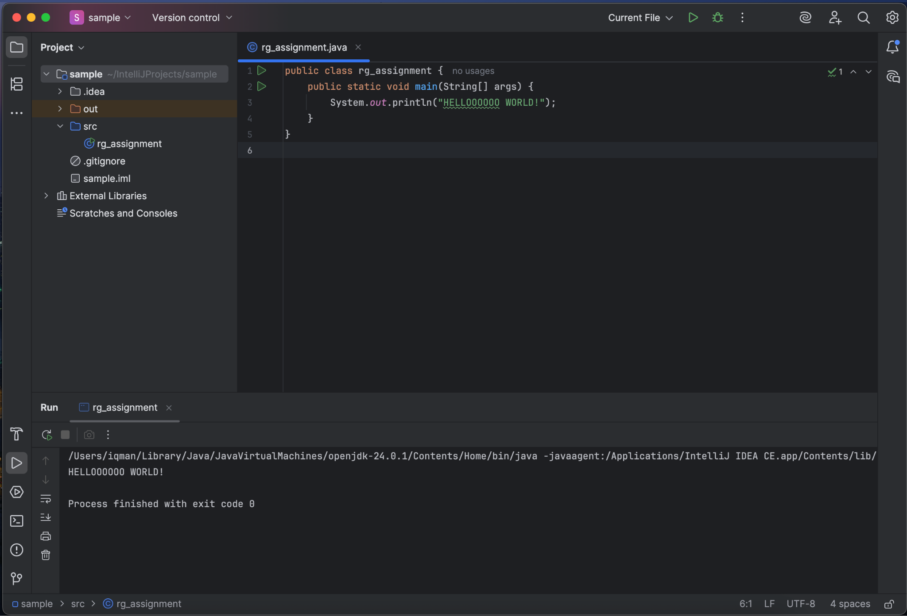

1. **In IntelliJ IDE, explore the shortcut keys for the following**
   1. To run the project: Shift + F10
   2. To select a line: Shift + End
   3. To comment/uncomment a line: Cmd + /
   4. To delete a line: Cmd + Delete